**How it works ?**

## Efficiently manage your case’s workflow with ACAMS

ACAMS is a user-friendly, cloud based solution designed to help you better manage your workflow, allowing your court to process cases faster and more efficiently.

ACAMS is an all-in-one, affordable and intuitive case management software designed. Give your firm the advantage of the best case management software solution – get organized with contacts, calendars, cases, documents, time tracking, and billing.

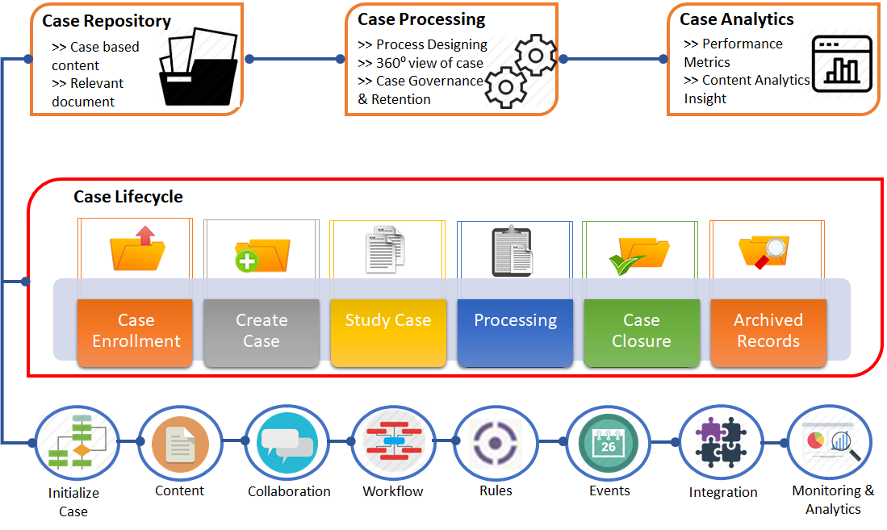

## Increased Mobility – Work From Anywhere

## One of the greatest benefits of cloud-based law firm management software is the flexibility you have to access your case and client information. Securely login from any computer or use the ACAMS app to take advantage of the time you spend commuting, waiting in court, or traveling. Get more done every single day.

## Adaptable and configurable

ACAMS easily adapts to meet your rules and critical processes. Rules can be changed quickly and easily without the need for technical support.

## Evolve with technology

Our engineers are continually working on new enhancements to make ACAMS software even more powerful, easier to use, and adaptable. As technology evolves, so does ACAMS.

## Unlimited Flexibility

Almost every element of our case management software can be tailored by you, to fit in 100% with your preferred way of working.   Screens, fields, documents, reports, workflow steps, queries… all can be tailored or created from scratch to ensure that Acro works around your every need.

## Process cases faster

ACAMS allows for seamless standards-based integration with other internal and external systems to provide the most efficient, streamlined workflow possible.

**Who we Serve?**

Acro is the US’s leading **Case Management Software** provider.  Our Case Management system is in use by various professionals in a vast range of sectors, including:

* Legal-Judicial court and law enforcement
* Insurance
* Charitable
* Health Care
* Government
* HR

**Pricing**

## ACAMS is affordable

## The modular nature of our product makes it affordable for all sizes and types of business – from smaller to larger, statewide installations.

## Three key elements of C-Track pricing

**License fee**– Based on the size of the clients you serve

**Implementation cost**– Derived from a gap analysis that helps us understand the scope of work required to fully integrate ACAMS into your current business

**Maintenance and support**– Annual fee that provides access to our continually updated core product and support staff

**Free Consultation**

